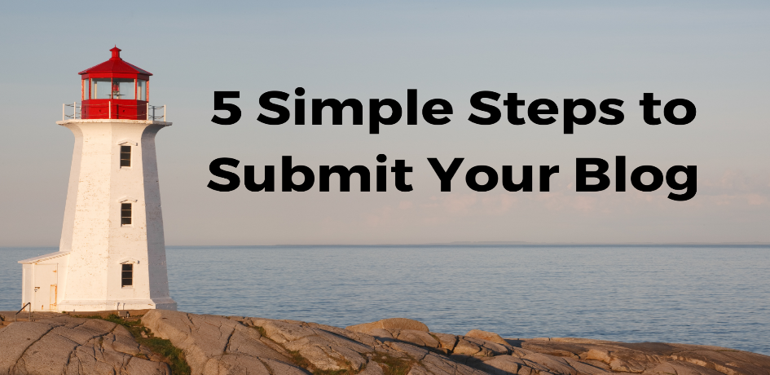

1. Choose a topic that is tour or travel related. Ideas include:

travel tips
best practices
travel trends
planning resources
destination info
research

While we encourage you to link to your own website in your content, please don’t use this platform as an advertisement for your business.

2. Create your content as a word doc. Content should be between 300 and 600 words. Please use headings and subheadings to separate your writing into easy-to-read sections.

3. Link content where appropriate. For example:
As a small group travel planner, you’ve probably spent some time on a motorcoach. However, just like many other businesses, the motorcoach industry was strongly affected by the pandemic (36,000 buses were brought to a standstill) and has made some changes.

4. Attach any photos you’d like to include. These should be at least 1400x600 pixels and credited appropriately.

5. Email your word doc and photos to michelle@gtonetwork.com. Include your full name, position, and company name.

That’s it! We’ll email you when your post is live on The Lighthouse so you can share on all your platforms as well.
We’re excited to spotlight YOU in the tour and travel industry!
*GTO reserves the right to refuse any publication we deem inappropriate, as well as the right to edit or adjust content to meet our branding standards.

